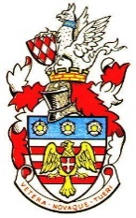
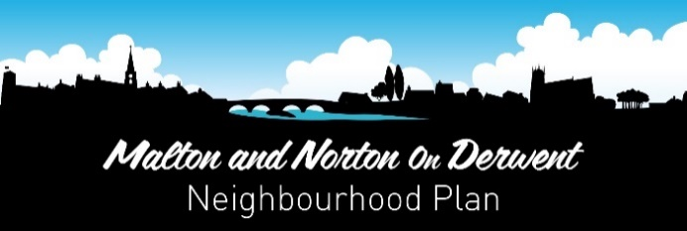
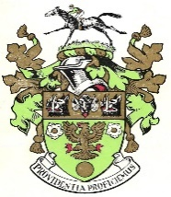

Malton Town Council and Norton on Derwent Town Council
c/o Norton on Derwent Town Council, The Old Courthouse, 84b Commercial Street, Norton, YO17 9ES
E-mail: norton.tc@btconnect.com

NEIGHBOURHOOD PLAN FOR MALTON AND NORTON 2019-2027
INFORMAL SITES CONSULTATION
To Whom It May Concern
The Neighbourhood Plan for Malton and Norton is being prepared by the two town councils through a steering group of councillors and local community representatives.
Neighbourhood Plans are a new type of community-led planning document introduced by Government in the 2011 Localism Act. They are part of a raft of new community rights to enable local communities to better shape their places. Once made (i.e. ‘adopted’) the Neighbourhood Plan for Malton and Norton will form part of the statutory development plan for Ryedale and its policies will be used by the district council to help determine planning applications and by inspectors in deciding appeals.
The plan is now at an advanced draft stage and contains many policies and proposals relating to individual sites and buildings within the area. This includes land and/or buildings in which you are understood to have a legal interest. For this reason we are now consulting you on the draft provisions of the plan which relate to your interests.
Enclosed, you will find a map showing the land/building to which this consultation relates and a summary of the Neighbourhood Plan policy being suggested for that land/building, together with an assessment of your land if categorised as Local Green Space. We now need you to tell us whether or not you agree with the policy and to make any associated comments in support of your response. (NB if the plan’s policies relate to more than one piece of land or building in which you are understood to have an interest, you will find the corresponding number of maps, policy summaries and assessments enclosed).
Responses can be made by post or by e-mail to the above addresses, using the enclosed response form, or by completing a form at one of the following scheduled community drop-in events to be held over the 3 week consultation period:-
- 23rd January – Malton Council Chambers (10am-7pm)
- 24th January – Norton Council Chambers (10am-7pm)

The consultation will run from Friday 11th January until Friday 1st February 2019. If you have any questions, please either e-mail us at the above address or ring us during normal office hours Malton Town Council (01653) 228699 or Norton Town Council (01653) 695348.
Following this consultation, the intention is to move to the statutory consultation on a final draft plan by mid-2019, after which the plan will be submitted to Ryedale District Council to organise an independent examination. We anticipate that the plan will come into force in late 2020, following a referendum of all electoral role voters within the Neighbourhood Area.
Yours sincerely

Clerks, of Malton and Norton on Derwent Town Council

